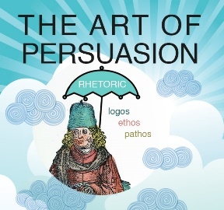

**Rhetorical Device Activity**

**Directions:** Rhetoric is the art of effective or [persuasive](https://www.google.com/search?safe=active&rlz=1C1GCEA_en&sca_esv=573826436&q=persuasive&si=ALGXSlbxwhdHKc0fpoiOcM6OGd45SaRYeIPjHd3rD0DJsYcgxp1y5SBw8Qn9EbsC-htOMCj02MASbqOutbLf1NXjziGRGbTcvQ%3D%3D&expnd=1) speaking or writing, especially the use of figures of speech and other [compositional](https://www.google.com/search?safe=active&rlz=1C1GCEA_en&sca_esv=573826436&q=compositional&si=ALGXSlaUkho42PFSQFYO6kO7MTs2qlwNNY8MtfA0XaxS8hXavh_YlwViOVQI_jJeVaTSFg7jbVP-0ooPx3zil0pZU9v6XEAJkRuZvY5JghB_L-RFp52MQmg%3D&expnd=1) techniques. There are many rhetorical devices that are used to enhance appeals (ethos, logos, and pathos) and persuade others. The most common rhetorical devices are the following:

Alliteration

Allusion

Anaphora

Antithesis

Hyperbole

Hypophora

Metaphor

Metonymy

Onomatopoeia

Parallelism

Personification

Points of View (or Narration Technique)

Rhetorical Question

Simile

Understatement

You will be given one of the following rhetorical devices. From there, you will use your creativity to teach us what that word means and give us an example. For instance, you could put the word on a google slide and define it. You could make the slide colorful, etc. You could then find a quick short movie clip (school appropriate) example of how your device is effectively used. You could also find a speech and highlight parts of the speech where your device is used correctly and use that as an example. Whatever you choose, you need to be creative, so we will all know, understand, and be able to identify each word in persuasive writings, speeches, movies, shows, commercials, etc. You will be writing down each of the words and their definitions/examples of the other devices that you do not have. The rubric is attached.

**RUBRIC**

You have defined your rhetorical device ___________ /5

You have provided an example ___________ /5

You were creative in your approach ___________ /5

You presented to the class (not staring at slides) ___________ /5

Total ___________ /20

Teacher Comments:

**RUBRIC**

You have defined your rhetorical device ___________ /5

You have provided an example ___________ /5

You were creative in your approach ___________ /5

You presented to the class (not staring at slides) ___________ /5

Total ___________ /20

Teacher Comments: